**Setting up OpenStack-Ansible All-In-One on a Centos 7 system**

 6 minute read   
**Date:**January 21, 2019



[Openstack](https://www.openstack.org/) is a nice platform to deploy [an Infrastructure as a service](https://en.wikipedia.org/wiki/Cloud_computing#Infrastructure_as_a_service_.28IaaS.29) and is a [collection of projects](https://governance.openstack.org/tc/reference/projects/index.html) but it can be a bit difficult to setup. [The documentation](https://docs.openstack.org/) is really great if you want to setup openstack by hand and there are a few openstack distributions that makes it easier to install it.

[Ansible](https://www.ansible.org/) is a very nice tool for system automatisation and is one that’s easier to learn.



Wouldn’t be nice if we could make the openstack installation easier with ansible? That’s exactly what [Openstack-Ansible](https://github.com/openstack/openstack-ansible) does.

In this blog post we’ll setup [“an all-in-one” openstack installation](https://docs.openstack.org/openstack-ansible/latest/user/aio/quickstart.html) on [Centos 7](https://www.centos.org/). The installer will install openstack into [lxc containers](https://linuxcontainers.org/) and it’s nice way to learn how openstack works and how to operate it.

**Preparation**

**System requirements**

I use a Centos 7 virtual system running as a [KVM](https://www.linux-kvm.org/) instance with [nested KVM virtualasation enabled](http://stafwag.github.io/blog/blog/2018/06/04/nested-virtualization-in-kvm/). The system requiremensts The minimun requiremenst are:

* 8 CPU cores
* 50 GB of free diskspace
* 8GB RAM

**update ….**

Make sure that your system is up-to-update

[staf@openstack ~]$ sudo yum update -y

We trust you have received the usual lecture from the local System

Administrator. It usually boils down to these three things:

#1) Respect the privacy of others.

#2) Think before you type.

#3) With great power comes great responsibility.

[sudo] password for staf:

Loaded plugins: fastestmirror

Loading mirror speeds from cached hostfile

* base: distrib-coffee.ipsl.jussieu.fr

* extras: mirror.in2p3.fr

* updates: centos.mirror.fr.planethoster.net

base | 3.6 kB 00:00:00

extras | 3.4 kB 00:00:00

updates | 3.4 kB 00:00:00

No packages marked for update

[staf@openstack ~]$

**Install git**

We’ll need git to install the ansible playbooks and the Openstack-Ansible installation scripts.

[staf@openstack ~]$ yum install git

Loaded plugins: fastestmirror

You need to be root to perform this command.

[staf@openstack ~]$ sudo yum install git

Loaded plugins: fastestmirror

Loading mirror speeds from cached hostfile

* base: mirror.in2p3.fr

* extras: mirror.in2p3.fr

* updates: centos.mirror.fr.planethoster.net

Package git-1.8.3.1-20.el7.x86_64 already installed and latest version

Nothing to do

[staf@openstack ~]$

**Ansible….**

This is a bit of a pitfail… The Openstack-Ansible bootstrap script will download and install his own version of ansible and create a link to /usr/local/bin. So /usr/local/bin must be in your $PATH. Ansible shouldn’t be installed on your system or if it is installed it shouln’t be executed instead of the ansible version that is builded with Openstack-Ansible.

On most GNU/Linux distributions have /usr/local/bin and /usr/local/sbin is in the $PATH but not on centos, so we’ll need to add it.

**Make sure that ansible insn’t installed**

[staf@openstack ~]$ sudo rpm -qa | grep -i ansible

[sudo] password for staf:

[staf@openstack ~]$

**Update your $PATH**

[root@openstack ~]# export PATH=/usr/local/bin:$PATH

If you want to have /usr/local/bin in your $PATH update /etc/profile or $HOME/.profile

**ssh password authentication**

The ansibe playbooks will disable PasswordAuthentication, make sure that you login with a ssh key. - Password authentication is obsolete anyway -

**firewalld**

Firewall is enabled on Centos by default, the default iptables rules prevent communication between the openstack containers.

**stop and disable firewalld**

[root@openstack ~]# systemctl stop firewalld

[root@openstack ~]# systemctl disable firewalld

Removed symlink /etc/systemd/system/multi-user.target.wants/firewalld.service.

Removed symlink /etc/systemd/system/dbus-org.fedoraproject.FirewallD1.service.

**verify**

root@openstack ~]# iptables -L

Chain INPUT (policy ACCEPT)

target prot opt source destination

Chain FORWARD (policy ACCEPT)

target prot opt source destination

Chain OUTPUT (policy ACCEPT)

target prot opt source destination

[root@openstack ~]#

**Openstack installation**

The installation will take some time therefor it’s recommended to use an session manager like [tmux](https://github.com/tmux/tmux/) or [GNU screen](https://www.gnu.org/software/screen/)

**Bootstrap**

**git clone**

clone the [openstack-ansible git repo](https://git.openstack.org/openstack/openstack-ansible)

[root@openstack ~]# git clone https://git.openstack.org/openstack/openstack-ansible /opt/openstack-ansible

Cloning into '/opt/openstack-ansible'...

remote: Counting objects: 67055, done.

remote: Compressing objects: 100% (32165/32165), done.

remote: Total 67055 (delta 45474), reused 52564 (delta 32073)

Receiving objects: 100% (67055/67055), 14.60 MiB | 720.00 KiB/s, done.

Resolving deltas: 100% (45474/45474), done.

[root@openstack ~]#

[root@openstack ~]# cd /opt/openstack-ansible

[root@openstack openstack-ansible]#

**choose you Openstack releases**

Openstack has release shedule about every 6 months the current stable release is [Rocky](https://releases.openstack.org/rocky/index.html). Every Openstack release has his own branch in the git repo. Each Openstack-Ansible release is tagged in the git repo. So either you’ll need checkout Openstack-Ansible release tag or the bracnh. We’ll checkout the Rocky branch.

**get the list of branches**

[root@openstack openstack-ansible]# git branch -a

* master

remotes/origin/HEAD -> origin/master

remotes/origin/master

remotes/origin/stable/ocata

remotes/origin/stable/pike

remotes/origin/stable/queens

remotes/origin/stable/rocky

[root@openstack openstack-ansible]#

**checkout the branch**

[root@openstack openstack-ansible]# git checkout stable/rocky

Branch stable/rocky set up to track remote branch stable/rocky from origin.

Switched to a new branch 'stable/rocky'

[root@openstack openstack-ansible]#

**Bootstrap ansible**

Execute scripts/bootstrap-ansible.sh this will install the required packages and ansible playbooks.

[root@openstack openstack-ansible]# scripts/bootstrap-ansible.sh

+ export HTTP_PROXY=

+ HTTP_PROXY=

+ export HTTPS_PROXY=

+ HTTPS_PROXY=

+ export ANSIBLE_PACKAGE=ansible==2.5.14

+ ANSIBLE_PACKAGE=ansible==2.5.14

+ export ANSIBLE_ROLE_FILE=ansible-role-requirements.yml

+ ANSIBLE_ROLE_FILE=ansible-role-requirements.yml

+ export SSH_DIR=/root/.ssh

+ SSH_DIR=/root/.ssh

+ export DEBIAN_FRONTEND=noninteractive

+ DEBIAN_FRONTEND=noninteractive

<SNIP>

+ unset ANSIBLE_LIBRARY

+ unset ANSIBLE_LOOKUP_PLUGINS

+ unset ANSIBLE_FILTER_PLUGINS

+ unset ANSIBLE_ACTION_PLUGINS

+ unset ANSIBLE_CALLBACK_PLUGINS

+ unset ANSIBLE_CALLBACK_WHITELIST

+ unset ANSIBLE_TEST_PLUGINS

+ unset ANSIBLE_VARS_PLUGINS

+ unset ANSIBLE_STRATEGY_PLUGINS

+ unset ANSIBLE_CONFIG

+ '[' false == true ']'

+ echo 'System is bootstrapped and ready for use.'

System is bootstrapped and ready for use.

[root@openstack openstack-ansible]#

**Verify**

scripts/bootstrap-ansible created /opt/ansible-runtime and create amd updated //usr/local/bin with a few links.

[root@openstack openstack-ansible]# ls -ld /opt/*

drwxr-xr-x. 5 root root 56 Jan 12 11:42 /opt/ansible-runtime

drwxr-xr-x. 14 root root 4096 Jan 12 11:43 /opt/openstack-ansible

[root@openstack openstack-ansible]# ls -ltr /usr/local/bin/

total 8

lrwxrwxrwx. 1 root root 32 Jan 12 11:43 ansible -> /usr/local/bin/openstack-ansible

lrwxrwxrwx. 1 root root 39 Jan 12 11:43 ansible-config -> /opt/ansible-runtime/bin/ansible-config

lrwxrwxrwx. 1 root root 43 Jan 12 11:43 ansible-connection -> /opt/ansible-runtime/bin/ansible-connection

lrwxrwxrwx. 1 root root 40 Jan 12 11:43 ansible-console -> /opt/ansible-runtime/bin/ansible-console

lrwxrwxrwx. 1 root root 39 Jan 12 11:43 ansible-galaxy -> /opt/ansible-runtime/bin/ansible-galaxy

lrwxrwxrwx. 1 root root 36 Jan 12 11:43 ansible-doc -> /opt/ansible-runtime/bin/ansible-doc

lrwxrwxrwx. 1 root root 42 Jan 12 11:43 ansible-inventory -> /opt/ansible-runtime/bin/ansible-inventory

lrwxrwxrwx. 1 root root 32 Jan 12 11:43 ansible-playbook -> /usr/local/bin/openstack-ansible

lrwxrwxrwx. 1 root root 37 Jan 12 11:43 ansible-pull -> /opt/ansible-runtime/bin/ansible-pull

lrwxrwxrwx. 1 root root 38 Jan 12 11:43 ansible-vault -> /opt/ansible-runtime/bin/ansible-vault

-rw-r--r--. 1 root root 3169 Jan 12 11:43 openstack-ansible.rc

-rwxr-xr-x. 1 root root 2638 Jan 12 11:43 openstack-ansible

Verify that ansible command is one that’s installed bu the Openstack-Ansible bootstrap script.

[root@openstack openstack-ansible]# which ansible

/usr/local/bin/ansible

**Bootstrap AIO**

[root@openstack openstack-ansible]# scripts/bootstrap-aio.sh

+ export BOOTSTRAP_OPTS=

+ BOOTSTRAP_OPTS=

+++ dirname scripts/bootstrap-aio.sh

++ readlink -f scripts/..

+ export OSA_CLONE_DIR=/opt/openstack-ansible

TASK [Gathering Facts] *****************************************************************************************************

ok: [localhost]

TASK [sshd : Set OS dependent variables] ***********************************************************************************

ok: [localhost] => (item=/etc/ansible/roles/sshd/vars/RedHat_7.yml)

TASK [sshd : OS is supported] **********************************************************************************************

ok: [localhost] => {

"changed": false,

"msg": "All assertions passed"

}

TASK [sshd : Install ssh packages]

<SNIP>

EXIT NOTICE [Playbook execution success] **************************************

===============================================================================

+ popd

/opt/openstack-ansible

+ unset ANSIBLE_INVENTORY

+ unset ANSIBLE_VARS_PLUGINS

+ unset HOST_VARS_PATH

+ unset GROUP_VARS_PATH

[root@openstack openstack-ansible]#

**Run the playbooks**

We’ll to run a few playbooks to setup the containers and our Openstack environment.

Move to the openstack-ansible playbook directory.

[root@aio1 ~]# cd /opt/openstack-ansible/playbooks/

[root@aio1 playbooks]# pwd

/opt/openstack-ansible/playbooks

[root@aio1 playbooks]#

and exexcute the playbooks.

[root@openstack playbooks]# openstack-ansible setup-hosts.yml

[root@openstack playbooks]# openstack-ansible setup-infrastructure.yml

[root@aio1 playbooks]# openstack-ansible setup-openstack.yml

If all goes well your openstack installation is completed.

You can verify the openstack containers with lxc-ls

[root@aio1 playbooks]# lxc-ls --fancy

NAME STATE AUTOSTART GROUPS IPV4 IPV6

aio1_cinder_api_container-c211b759 RUNNING 1 onboot, openstack 10.255.255.43, 172.29.237.244, 172.29.244.190 -

aio1_galera_container-9a90cbd9 RUNNING 1 onboot, openstack 10.255.255.50, 172.29.239.126 -

aio1_glance_container-c05aab79 RUNNING 1 onboot, openstack 10.255.255.218, 172.29.236.160, 172.29.247.238 -

aio1_horizon_container-81943ba2 RUNNING 1 onboot, openstack 10.255.255.160, 172.29.237.37 -

aio1_keystone_container-a5859104 RUNNING 1 onboot, openstack 10.255.255.40, 172.29.236.95 -

aio1_memcached_container-ab998d0e RUNNING 1 onboot, openstack 10.255.255.175, 172.29.239.49 -

aio1_neutron_server_container-439aeb90 RUNNING 1 onboot, openstack 10.255.255.137, 172.29.239.13 -

aio1_nova_api_container-c83e5ef0 RUNNING 1 onboot, openstack 10.255.255.216, 172.29.236.52 -

aio1_rabbit_mq_container-4fd792fb RUNNING 1 onboot, openstack 10.255.255.2, 172.29.239.62 -

aio1_repo_container-b39d88a1 RUNNING 1 onboot, openstack 10.255.255.227, 172.29.237.146 -

aio1_utility_container-fff0b6df RUNNING 1 onboot, openstack 10.255.255.117, 172.29.237.82 -

[root@aio1 playbooks]#

**Find the correct ip address**

You should see horizon running with netstat

[root@aio1 ~]# netstat -pan | grep -i 443

tcp 0 0 172.29.236.100:443 0.0.0.0:* LISTEN 12908/haproxy

tcp 0 0 192.168.122.23:443 0.0.0.0:* LISTEN 12908/haproxy

unix 3 [ ] STREAM CONNECTED 73443 31134/tmux

unix 2 [ ] DGRAM 1244303 23435/rsyslogd

[root@aio1 ~]#

**Logon to the openstack GUI (Horizon)**

**Password…**

[root@aio1 ~]# grep keystone_auth_admin_password /etc/openstack_deploy/user_secrets.yml

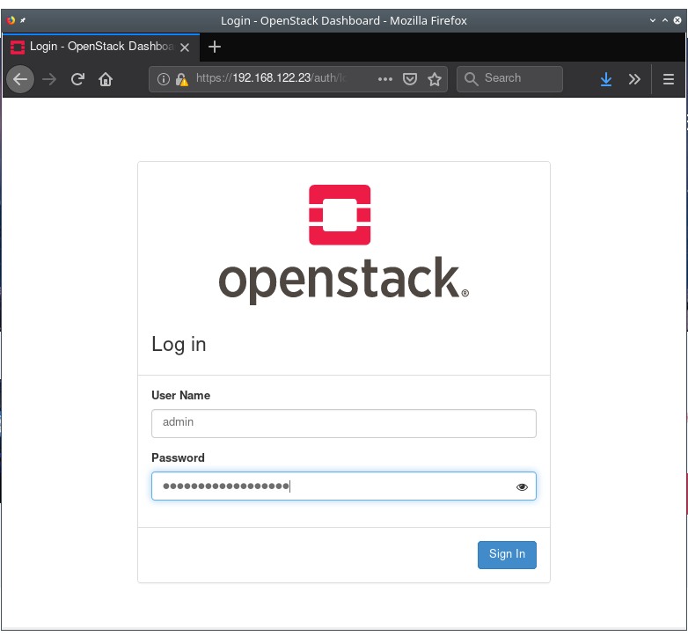

*\*\* Have fun \*\**

**Links**

* <https://docs.openstack.org/openstack-ansible/latest/user/aio/quickstart.html>
* <https://docs.openstack.org/project-deploy-guide/openstack-ansible/queens/deploymenthost.html>
* <https://bugs.launchpad.net/openstack-ansible/+bug/1792050>
* <https://docs.openstack.org/openstack-ansible-security/latest/auto_controls-all.html>
* <https://blog.christophersmart.com/2016/08/09/setting-up-openstack-ansible-all-in-one-behind-a-proxy/>